In 2009, Three for the Road will offer a Family Day on September 13. The event will take place at Legion Park, Hollidaysburg. Check in is at 1:00 and the walk starts at 2:00 PM. Interested walkers/donors should contact Julie at 943-1282 or Sandra at threefortheroadwalk@gmail.com

In addition to the walk, people will be able to visit with Steamer & Daniel the Lion, as they kick off the walk. We will also have the Altoona Area High School Football Team, a dunking booth, petting zoo, Fat Daddy’s Wings on hand to help us celebrate.

We will hold a cash and basket raffle with many great donations! We will have the third year of our Stained Glass collection. The raffle will run from 1:00 to about 4:00 and then we'll announce the winners. The items range from Pampered Chef to scrapbooking to jewelry; local sporting stores and teams have donated baskets, too! There will be many games and activities for the children and music to enjoy, as well as a full concession stand.

Our journey started in 2006. Ethan Knepp, at age 11, designed his service project to teach people about the risks and realities of lung cancer in non-smokers. In August 2006, Ethan experienced the death of a close family friend, Karen Eckenrode. Karen went to the doctor for persistent coughing in August 2005. She was not diagnosed with lung cancer until March 2006 because the doctors do not routinely order a chest x-ray for a non-smoker. Karen died at age 37 of lung cancer on August 26, 2006. Ethan wants to stop this from happening to others - lung cancer is now the most common cancer diagnosed in the U.S. Earlier diagnosis leads to more immediate treatment and increased likelihood of remission.
Ethan plays little league baseball. His coach’s’ wife has lived with a life-altering illness since 1998. Julie Newberry, who has Arnold Chiari Malformation (CM) and Syringomyelia (SM) has been looking for a way to increase awareness and support. Julie went undiagnosed for 7 years with excruciating headaches caused by light, numbness and tingling in her hands and feet, muscle weakness and eventually losing function in her hands because the doctors were unfamiliar with the conditions. A doctor in Pittsburgh knew what she had by ordering a simple MRI. This led to many trips to Pittsburgh and 4 more surgeries. Julie feels that it is her obligation to help others. There are 1 in 1,900 Americans diagnosed with SM.
We have also recognized the increasing number of children diagnosed with Autism Spectrum Disorders. In PA, 1 in 150 children are diagnosed with Autism/ Asperger’s Disease. These numbers are expected to rise. Without effective early treatment, these children may not be able to live the quality of life we wish for all children.

We have worked together to help ourselves, those we love, and people we haven’t met yet because these causes are important; lives change drastically. Ethan, Julie, and others want to raise funds and awareness to support people with these serious illnesses. We need to make a difference one step at a time.

To accomplish our mission, we held our first Annual Walk on September 30, 2007. We were able to raise funds for the American Lung Association, Bloomin’ Youth Autism Program, and American Syringomyelia Alliance Project. We honored Karen’s family and her fight with lung cancer. The community responded by helping us to make our donations and cover most of our costs.

We now look to you as we continue working toward our dream – a world where children and families can live and be healthy.

Thank You for working together…sharing the dream…

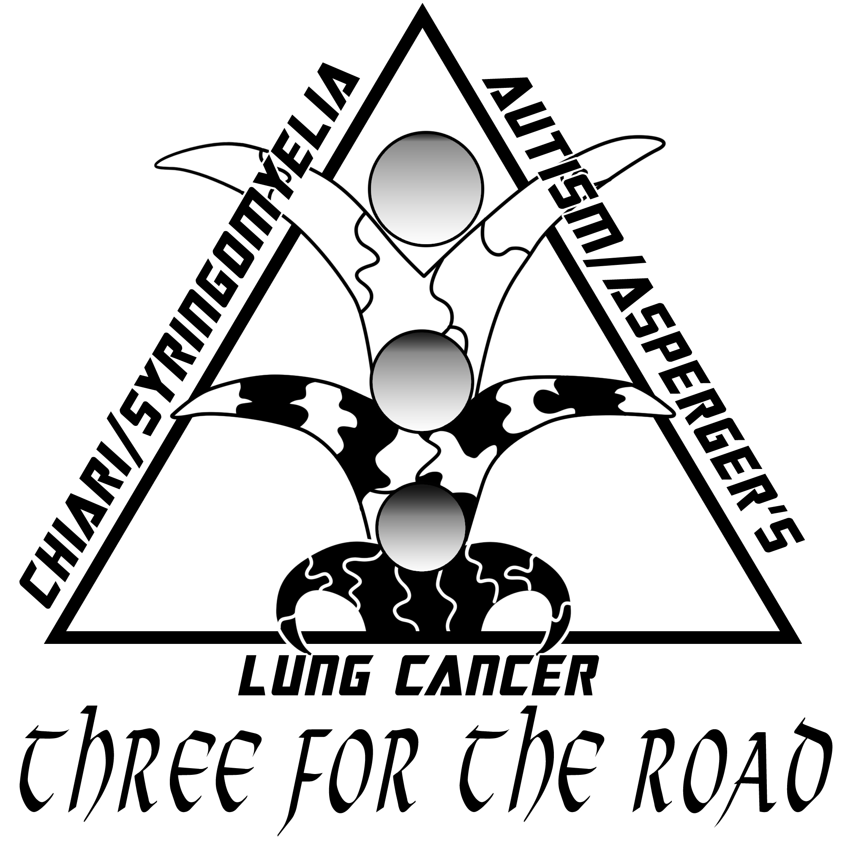
3rd Annual
Three for the Road
Family Day/Walk

September 13. 2009

Legion Park, Hollidaysburg, PA

Enjoy this year’s fun with the Altoona Area High School Football Team, Fat Daddy’s Wings, basket & cash raffle, dunking booth, games, music, Clover Creek petting zoo, Our Dream Wall, Steamer, Daniel the Lion, good food & much more!

Check out our community sponsors and
be inspired by stories from our Honored Friends!

$25 Pre-Registration/person
includes one TFTR t-shirt!

$175 Pre-Registration for 8 person team – with 8 t-shirts!

$30 Registration on Event Day /person includes one t-shirt!

